1. 原来接的是I2C2 M0，现改为接I2C2 M1

Connect I2C2 M1 instead of I2C2 M0

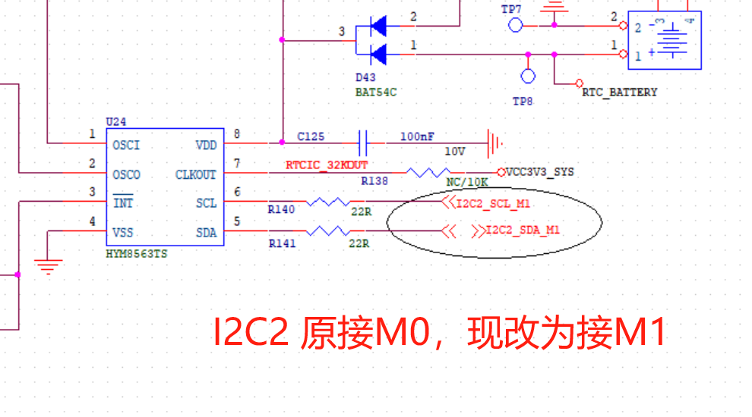

1. 版本号原V1.35, 现改为V1.36

Change HW Version Number from V1.35 to V1.36

1. 拼板改成邮票孔，分板

**Change panel to stamp holes for depanelization**