- Change the silk screen on the PCB to ROCK 5A V1.2

- Modify schematic
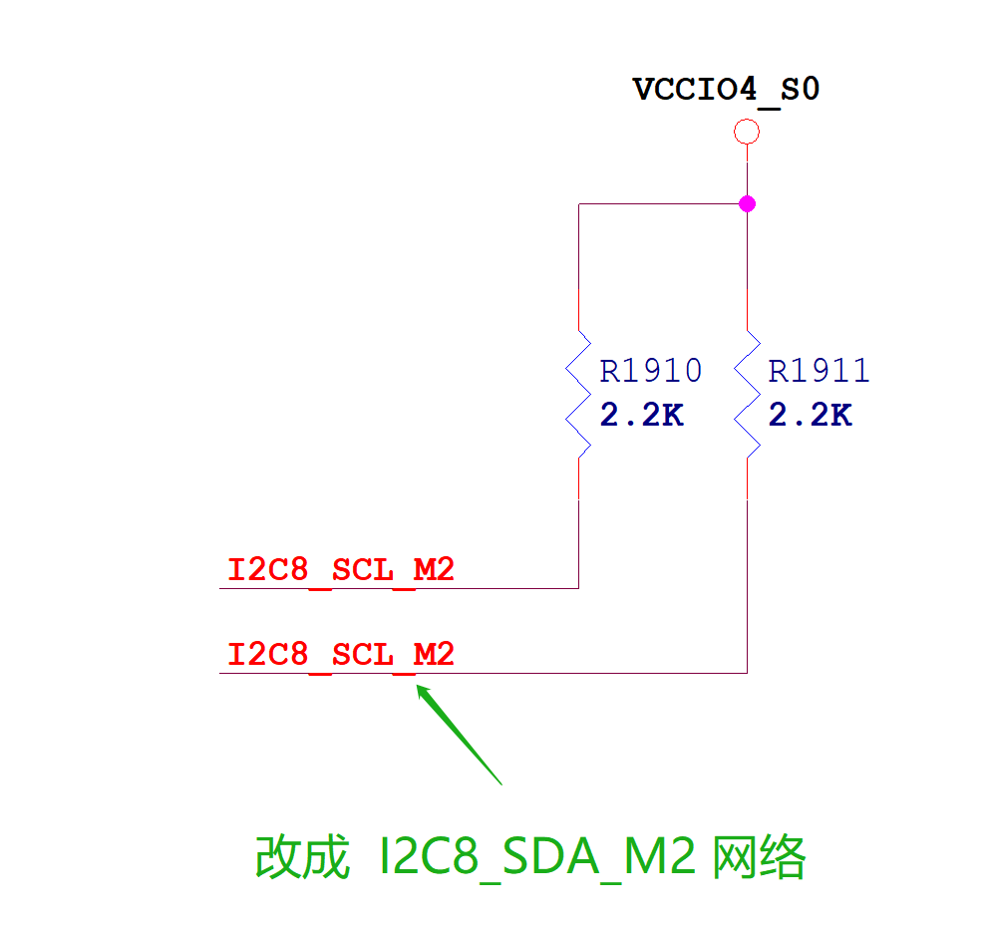

3.Modify layout

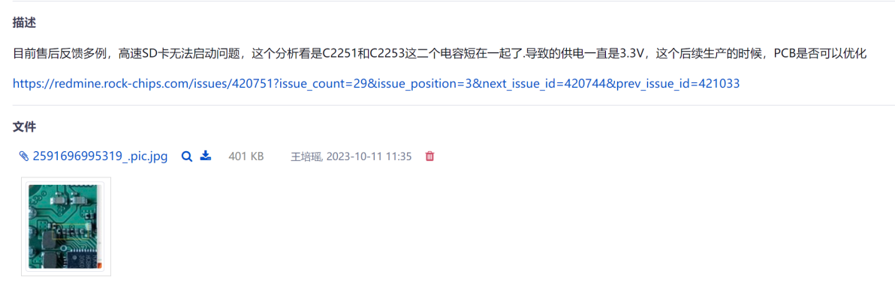

- Change BOM Package for R95239

- Remove optional circuit for SPI FLASH

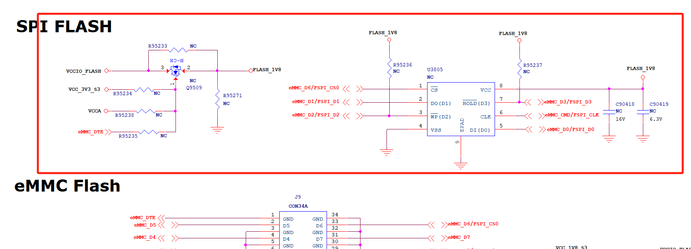

- Increase the routing area for the VCC_1V8_S3 net

